

**“No Man Left Behind”** Youth Retreat

Registration Form (Luke 15)

*Date:* Friday, August 14, 2015 to

Sunday, August 16, 2015

*Location:* Camp Sacajawea

3910 Chestnut Street

Wisconsin Rapids, WI 54494

*Registration Fee:* $5.00

***All application forms and registration fees will be due on***

***Sunday, August 2nd to Friday, August 14.***

**If you have any questions or concerns contact:**

Pastor Tonying Thao at 1-630-962-8830 or tonyingthao@yahoo.com

Youth Secretary: Molly Mao Her at 1-517-662-2103 or hawjlove2@gmail.com

Youth Treasure: Mai Neng Kha at 715-297-7011 or khamaineng@gmail.com

**“No Man Left Behind” Youth Retreat Registration Form**

Name:________________________________________________________________________

Address:______________________________________________________________________

City: State: Zip Code:

Home Phone Number: (_____)_______________ Cell Phone Number:( ) -

Date of Birth: ______/_________/__________

**List Two Emergency Contacts: (***This information will remain confidential and will only be used in case of emergency)*

**Emergency Contact 1 Name:**_____________________________________________________

Address:______________________________________________________________________

City: State: Zip Code:

Home Phone Number: (_____)_______-________ Cell Phone Number:( ) -

Work Phone Number: ( ) - Relationship:

**Emergency Contact 2 Name**:_____________________________________________________

Address:______________________________________________________________________

City: State: Zip Code:

Home Phone Number: (_____)_______-________ Cell Phone Number:( ) -

Work Phone Number: ( ) - Relationship:

**Please include the following health insurance information:**

Company:

Identification #:

Group #:

Medical Conditions or Allergies (Please be specific and if applicable, please list medications and instructions):

**Youth Retreat Camp Rules**

1. All water activities prohibited (i.e. Canoeing, swimming, etc..)
2. Boys and girls will be placed in separate sleeping quarters.
3. Wandering off the campsite at the camp ground is prohibited.
4. No fires, lighters, or candles allowed.
5. Curfew is midnight, Everyone is excepted to be in bed by midnight; no other activities allowed.
6. Use the buddy system.
7. No horseplay.
8. Wear shoes at all times on the camp grounds.
9. Large amounts of money is unnecessary. First Hmong Missionary Alliance Church cannot be responsible for missing money.
10. Responsible and respectful behavior is expected at all times.

Repeated warnings will result in disciplinary action including immediate dismissal from the camp. A parent called for a behavior problem resulting in dismissal must make sure their child is picked up within four hours of being called, or the alternate contacts on the application will be called.



Cut Cut Cut

**Check off List** *(of items and things you will need)*

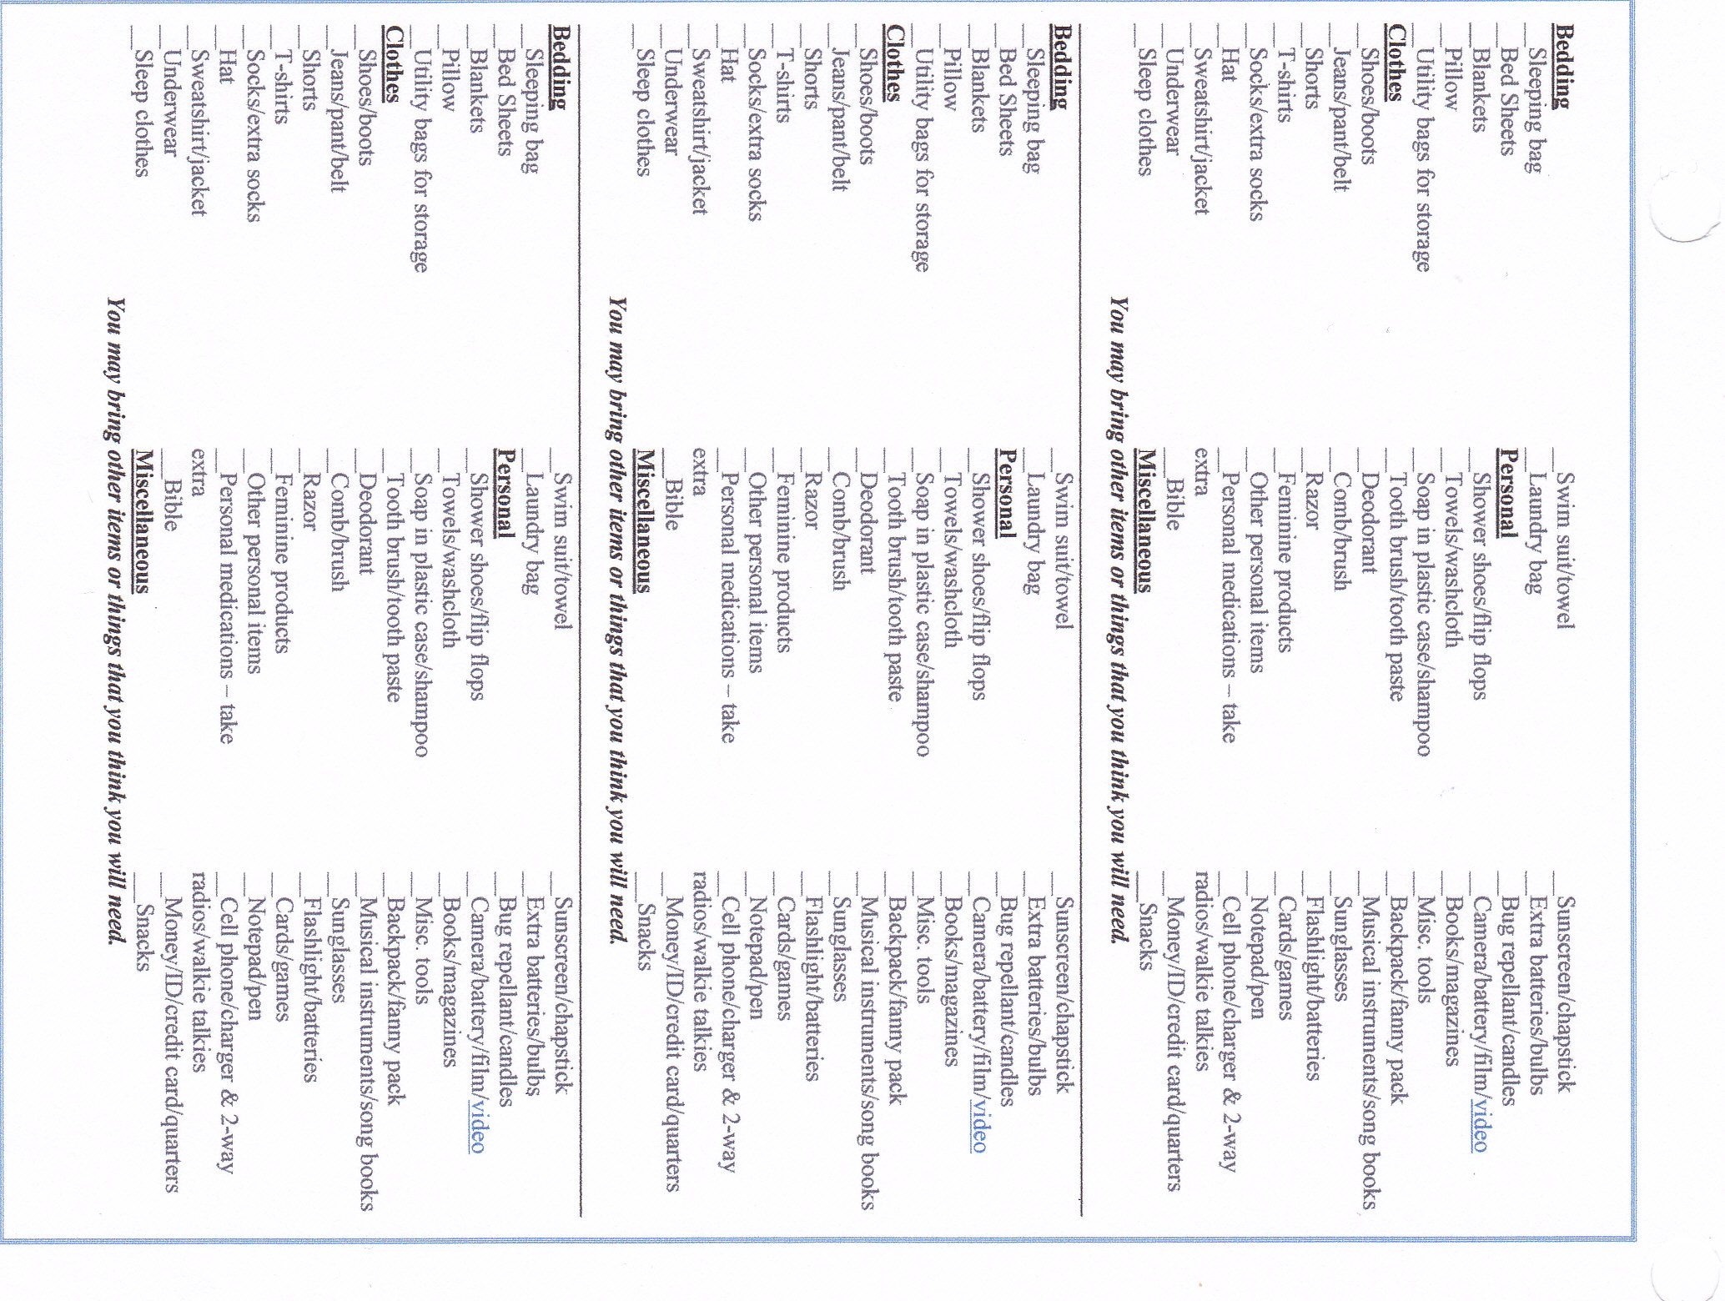

**PARENTAL CONSENT**

The undersigned does hereby give permission for to attend and participate in the Wausau First Hmong Missionary Alliance Youth Retreat starting August 14th 2015 at 3:30pmto August 16th 2015 at 4:00pm located at Camp Sacajawea in Wisconsin Rapid.

**LIABILITY RELEASE:**

In consideration of Wausau First Hmong Missionary Alliance Church, allowing the Participant to participate in the Youth Retreat, I, the undersigned, do hereby release, forever discharge and agree to hold harmless Wausau First Hmong Missionary Alliance Church, its pastors, directors, employees, volunteers and teachers (collectively herein Wausau First Hmong Missionary Alliance Church) from any and all liability, claims or demands for accidental personal injury, sickness or death, as well as property damage and expenses, of any nature whatsoever which may be incurred by the undersigned and the Participant while involved in the youth activities. I, the parent or legal guardian, of this Participant hereby grants my permission for the Participant to participate fully in youth ministry activities. Furthermore, I, on behalf of my minor Participant, hereby assume all risk of accidental personal injury, sickness, death, damage and expense as a result of participation in recreation and work activities involved therein. The undersigned further hereby agrees to hold harmless and indemnify Wausau First Hmong Missionary Alliance Church for any liability sustained by Wausau First Hmong Missionary Alliance Church as the result of the negligent, willful or intentional acts of said Participant, including expenses incurred attendant thereto.

_________________________________________________________________

Name of minor participant Date

_________________________________________________________________

Signature of minor participant Date

_________________________________________________________________

Name of parent/guardian Date

_________________________________________________________________

Signature of parent/guardian Date

**If the Participate is of 18 years of age and over, please sign below in agreement to terms stated in Liability Release and Camp Rules:**

_______________________________________________________________

Name of Participant Date

Signature of Participant Date